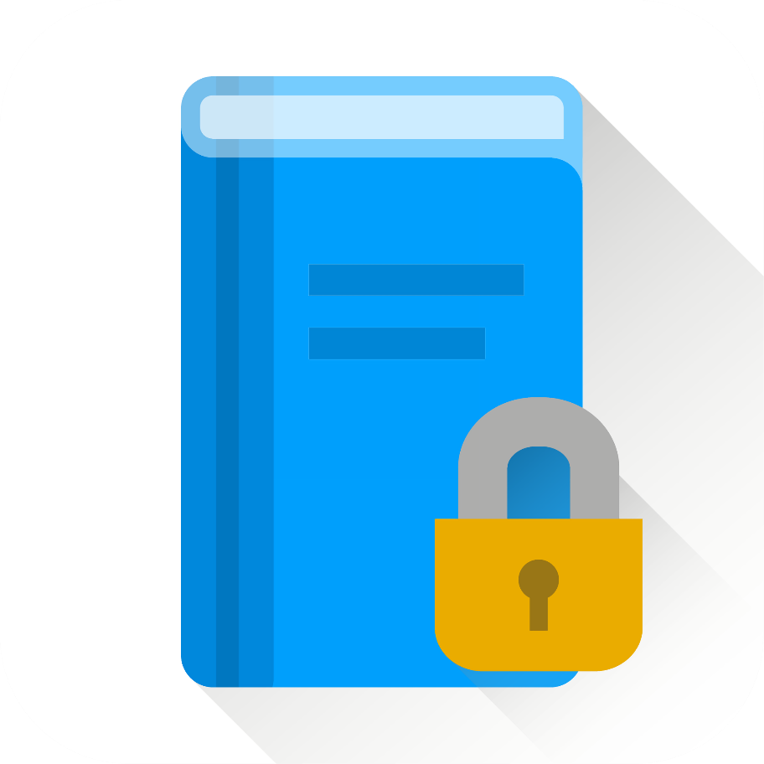

Study Locker

|  |  |
| --- | --- |
| Work | faster,  smarter,  easier. |